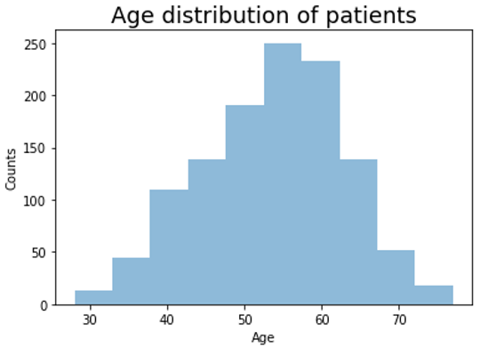

(**fig 1.** The bar graph represents the age distribution of patients. The x-axis represents the age and the y axis represents counts of number of people in that age group )

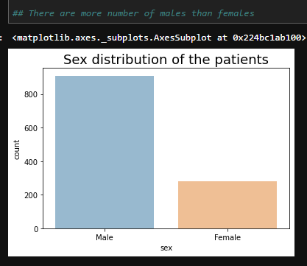

**(fig 2.** The bar graph represents the sex distribution of patients. The x-axis represents the sex and the y axis represents counts of number of people in that age group )

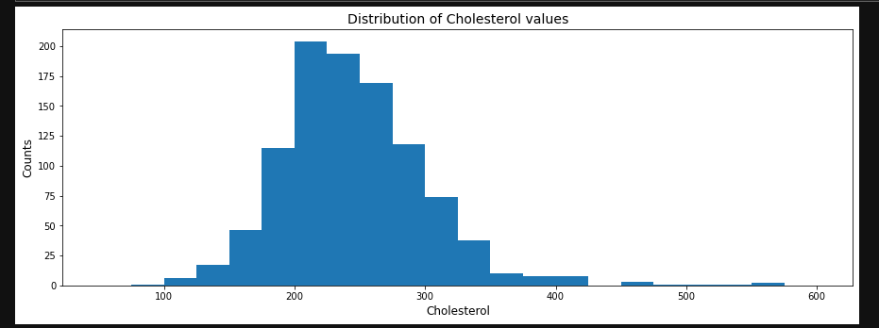

(**fig 3** Graphical representation of Cholesterol Values , ranging from 250 to 600 , majorly the cholesterol is in the range of 200-350 , x axis represent cholesterol and y axis represents number of people in that age group )

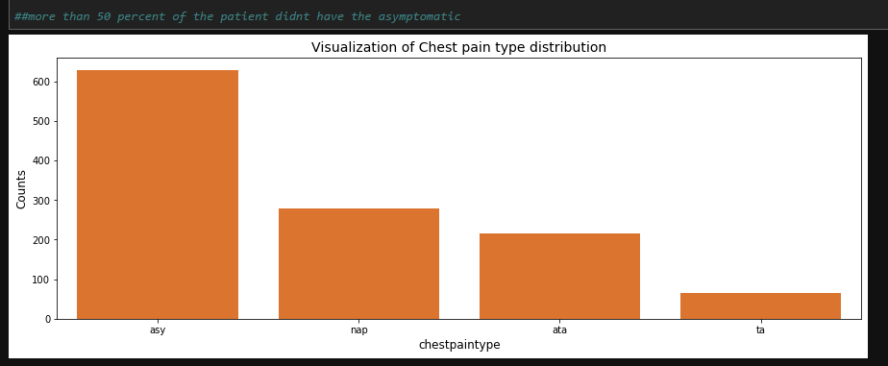

(**fig 4.a** represents the visualization of chest pain types asy ,nap,ata and ta. Majorly people have a chest pain type of asy ranging around 600. **Fig 4.b** is a basic representation using a pie chart)

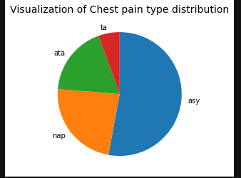

(**Fig 4.b**)

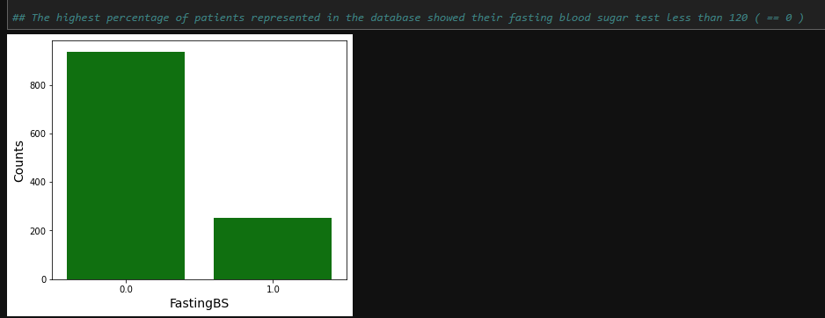

(**fig 5** Graphical representation of Fasting blood sugar. Evidently showing majorly people have 0 fasting blood sugar in a range of 800 . and less people in a range of 1)

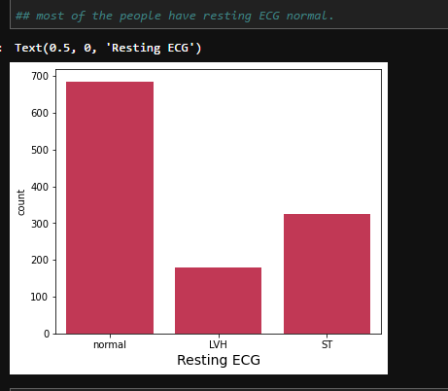

(**Fig 7.a** graphical representation of ECG , the bar graphs rightly shows that majorly people have normal ECG. Very less people have ST and least have LVH resting ECG.**Fig 7.b** Pie chart Representation of resting ECG)

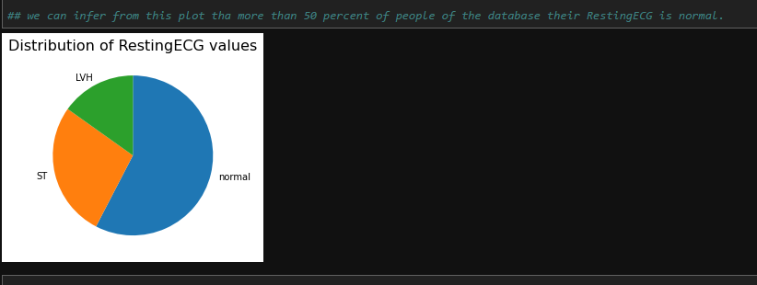

(**Fig 7.b**)

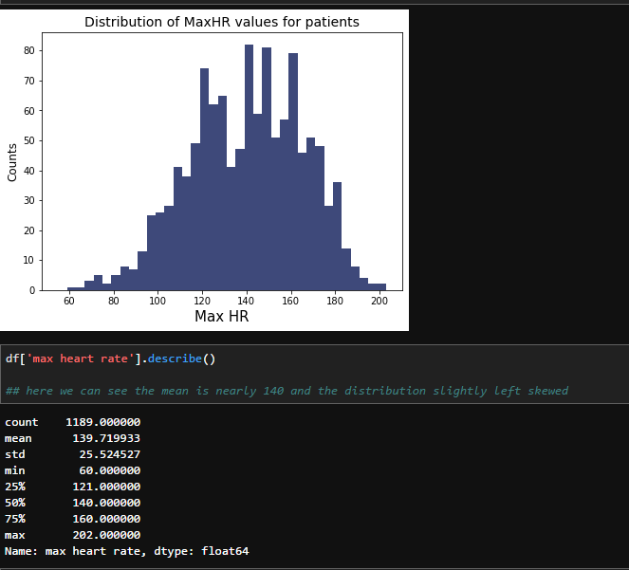

(**Fig 8** Distribution of Max HR values for patients. The mean of the maximum heart rate value is 140 and the graph is slightly left skewed. X axis shows Max HR and y axis the number of people)

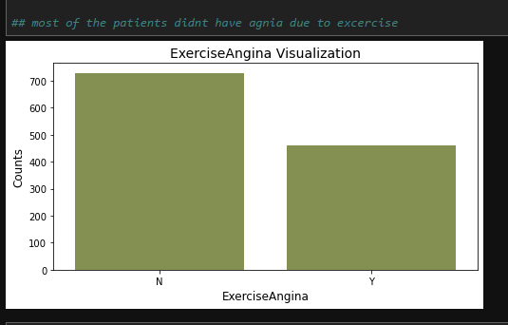

(**fig 9.** Graphical representation of Exercise Angina, Maximum people do not have exercise angina while 400 people have it)

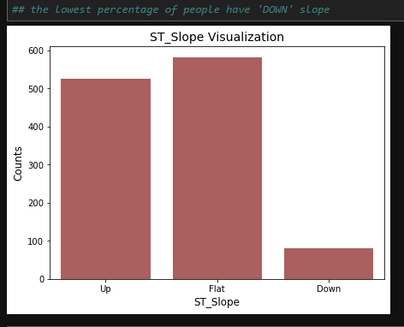

( **fig 10** Graphical representation of St Slope. People having Flat St slope are higher in range in compared to Up and Down. Lowest percentage of the people have DOWN slope.)

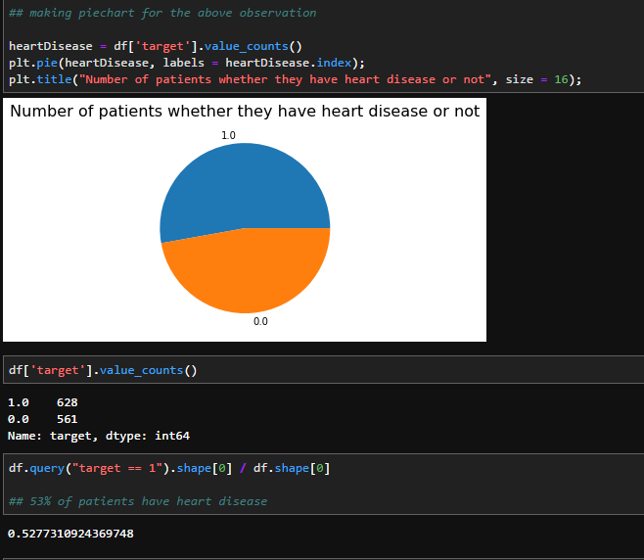

(**Fig 11**. Graphical representation of people having a heart disease or not. 1 represent having heart disease and 0 represent not having heart disease. From the given pie chart we can infer that about 53% of the patients have heart disease)

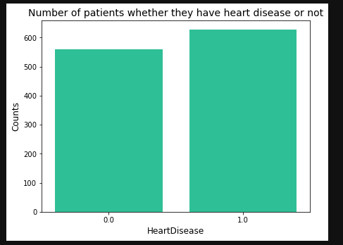

(**Fig 12** Graphical representation of number of Patients having a heart Disease or not with the number of people in that range. The graph rightly shows that major number of people have heart disease)

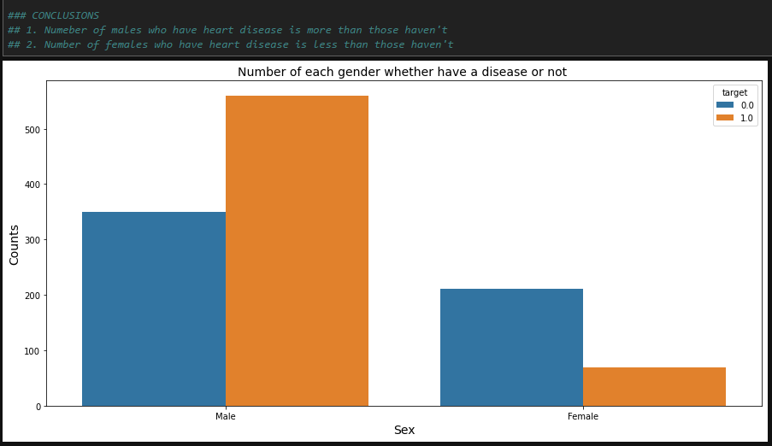

(**Fig13.a.** Graphical representation of number of each gender having a disease or not. The bar graph rightly shows that male have high risk of heart diseases as compared to females. 1. Number of males who have heart disease. 2. Number of females who have heart disease.)

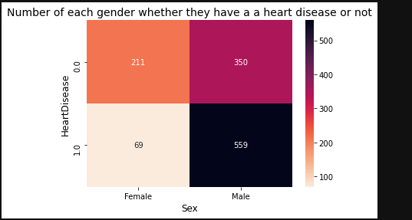

**(Fig 13.b**. Box graphical representation number of each gender having a disease or not. 350 males have high risk and 69 females with no heart disease and no heart risks)

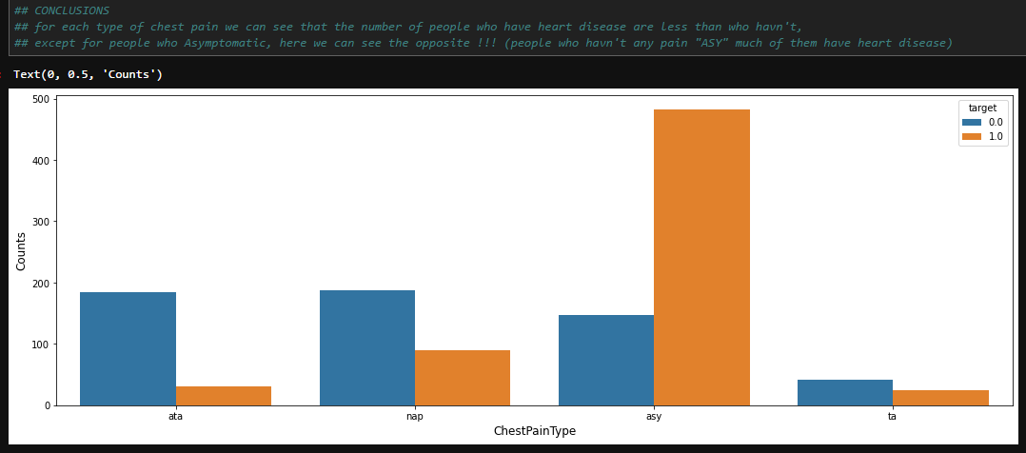

(**Fig 14.a** Graphical representation of chest pain type V.S Heart disease. The people having heart disease and chest pain type as asymptomatic are high in numbers whereas people with heart disease and chest pain type ta are the least)

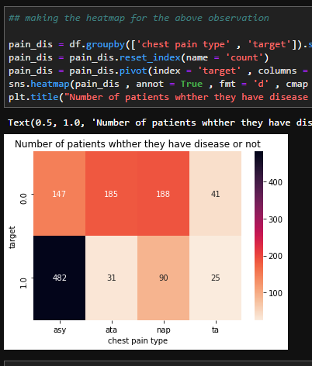

(**Fig 14.b** Box Graphical representation of chest pain type V.S Heart disease. 482 people having asymptomatic and heart disease are high in numbers. 25 people having chest pain type ta and a heart disease are least)

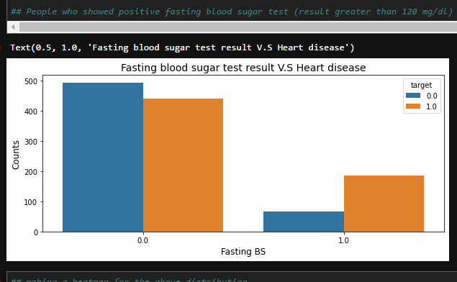

(**Fig15.a** Graphical representation of Fasting Blood Sugar test vs Heart Disease. People who have showed positive fasting blood sugar test(result > 120 mg/dl) are more likely have heart disease , although the number of people who have heart disease (whose test results == 0) is more than who haven’t.)

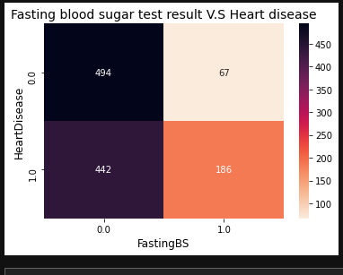

(**Fig 15.b** Box graphical representation of people having of Fasting Blood Sugar and heart disease. 494 people who do not have heart disease and Fasting BS as 1 is the highest in number. Whereas 67 people having Fasting BS as 1 and no hear disease are the lowest)

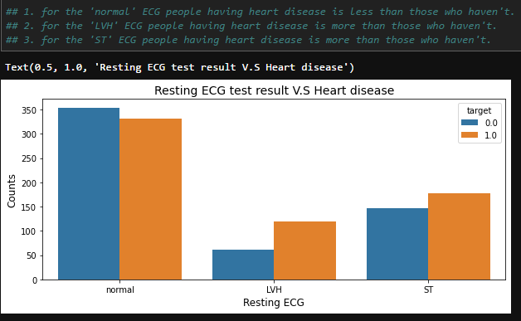

(**fig 16.a** The graphical representation of ECG Test results vs the heart disease. Majorly people who have ECG reading normal have less heart risk as compared to people in LVH and ST. **‘normal’** ECG people having heart disease is less than those who haven’t**. ‘LWH’** ECG people having heart disease is more than those who haven’t **‘ST’** ECG people havimg heart disease is more than those who haven’t.

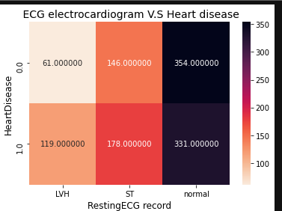

(**Fig 16.b** The graphical representation of ECG electrocardiogram and heart disease. 354 people who have ECG reading Normal have no heart risk are less in range and 61 people having LVH ECG reading and no prior hear disease are the least.)

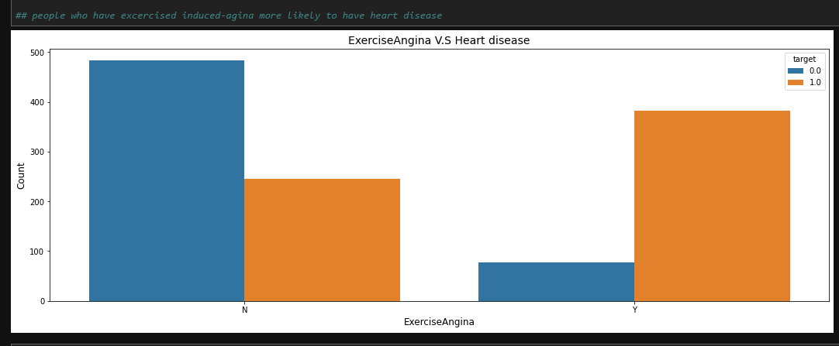

(**fig 17.a** Graphical representation of Exercise Angina V.S heart Disease. The X axis shows people having Angina or not in a range of 0-1 , The Y axis shows the number of people having having exercise Angina. The graph shows majorly people do not have exercise Angina in a value of 0. )

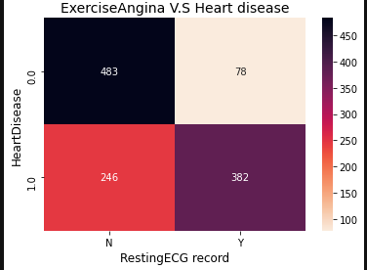

**(Fig17. b** shows the block graphical representation of Exercise Angina and heart Disease. 382 people who have heart disease and have resting ECG have high risk of heart disease. Whereas 78 people who have heart disease and ECG 0 are lowest in the range.)